Create a S3 bucket, with no public access and upload files to the bucket & view the logs for the uploaded files. Launch two ec2-instances and connect it to a application load balancer, where the output traffic from the server must be an load balancer IP address.

**Solution:-**

Creating a S3 bucket, Bucket name is “do21we”

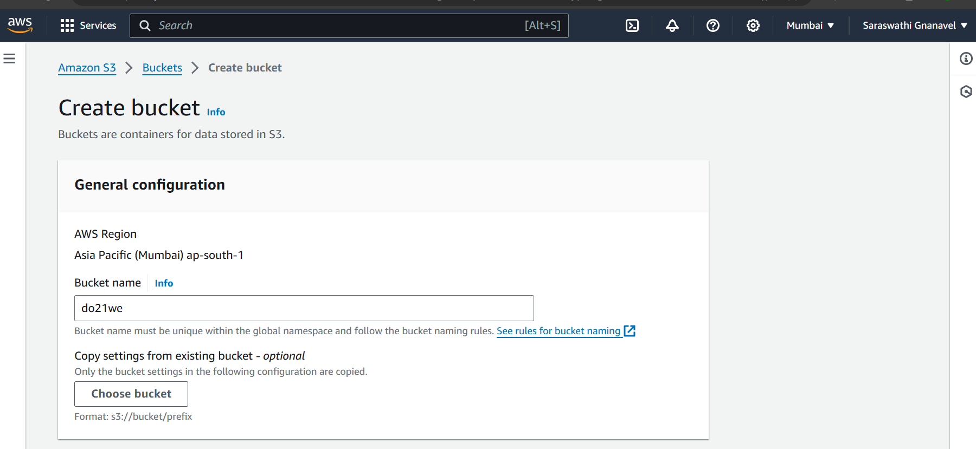

No pubic access has been given

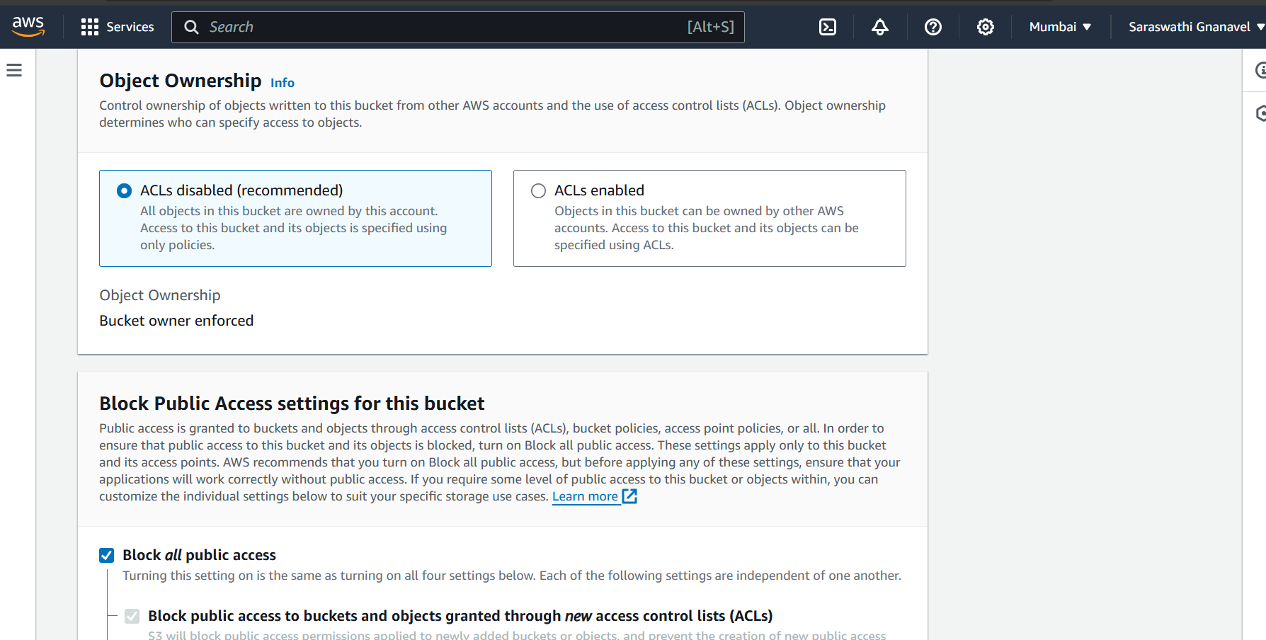

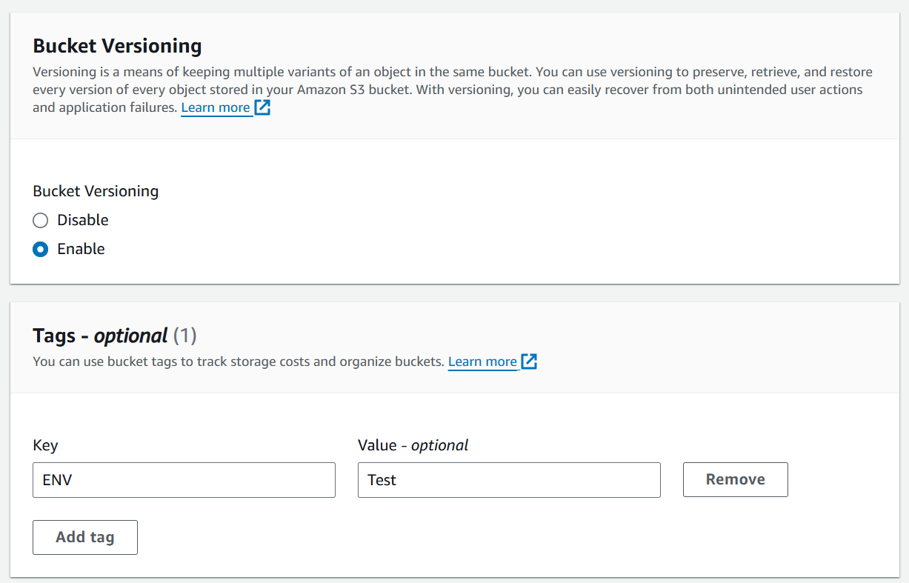

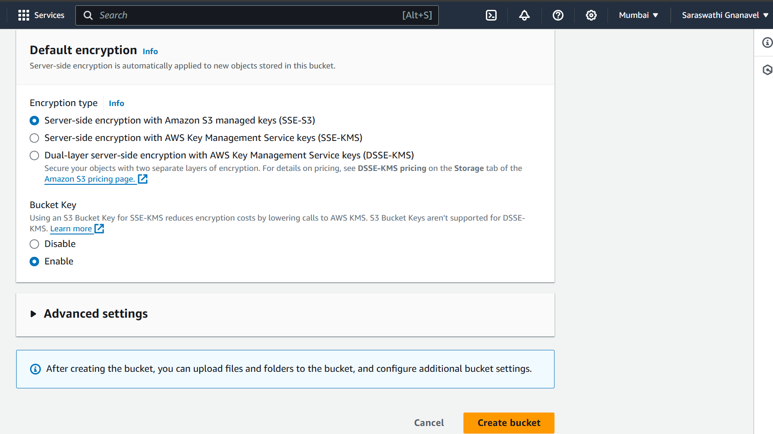

Bucket has been created

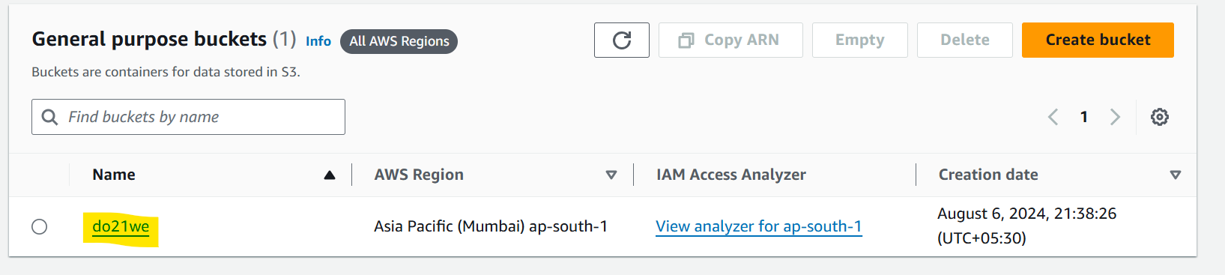

Upload Testing.txt file to the bucket

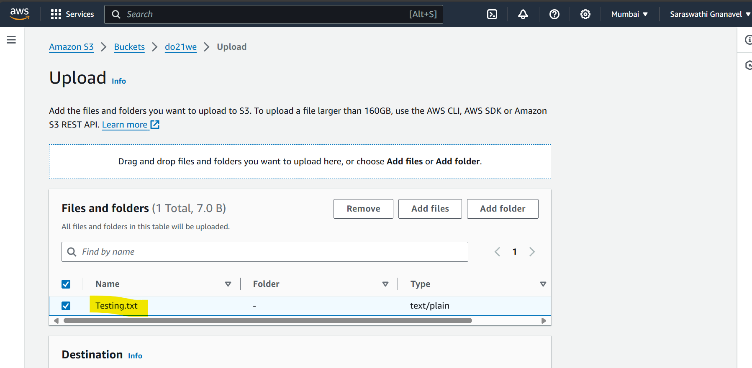

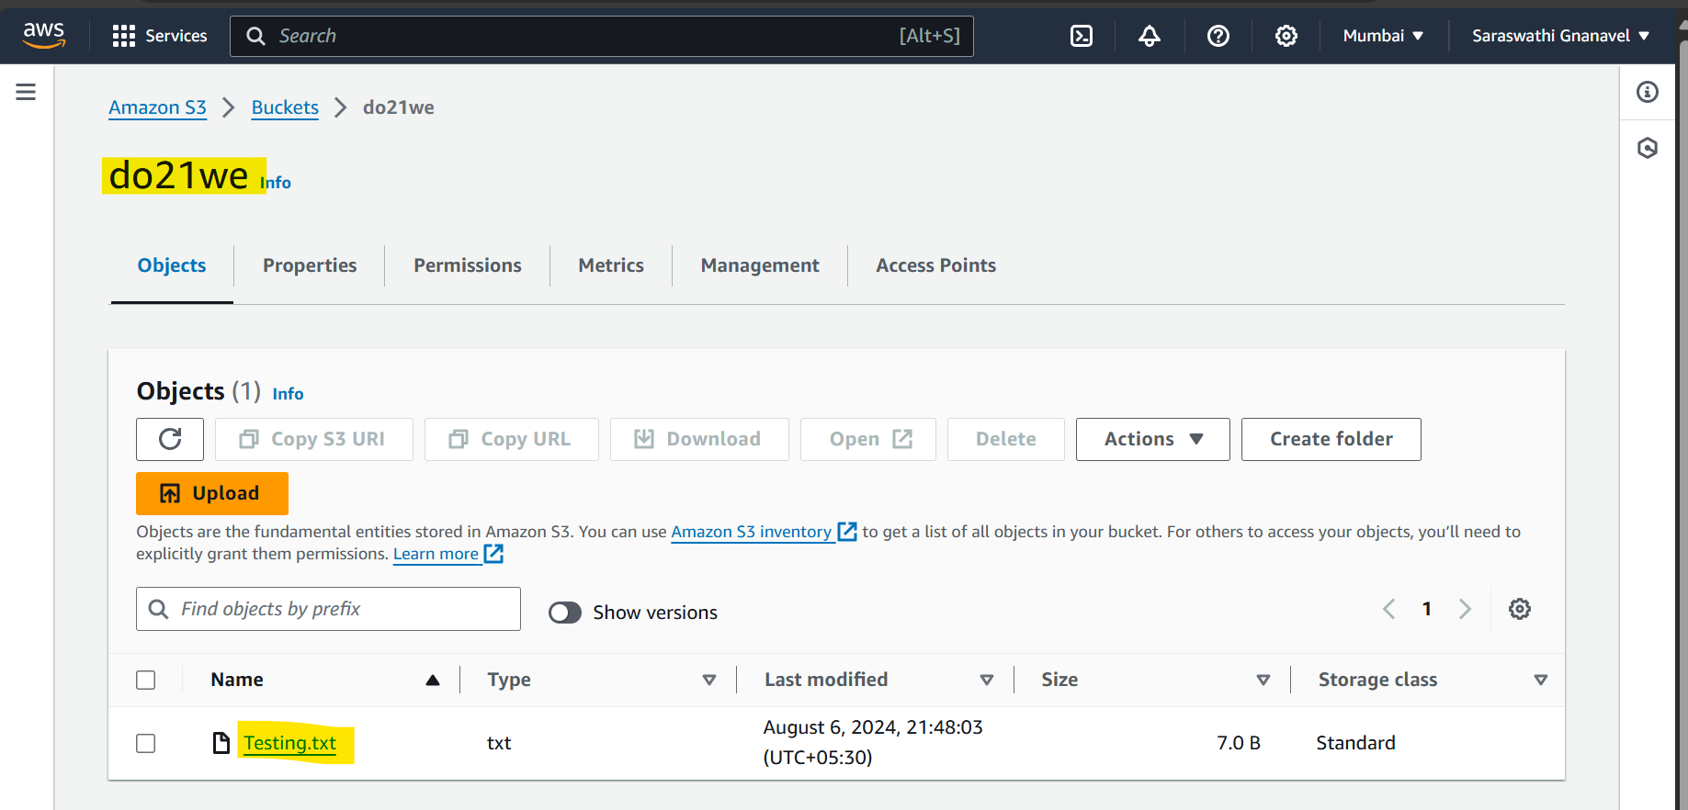

Enabling access logs

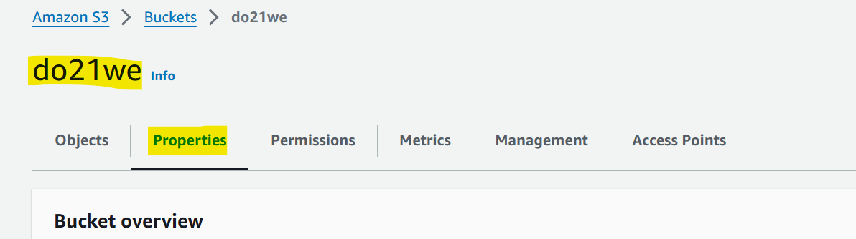

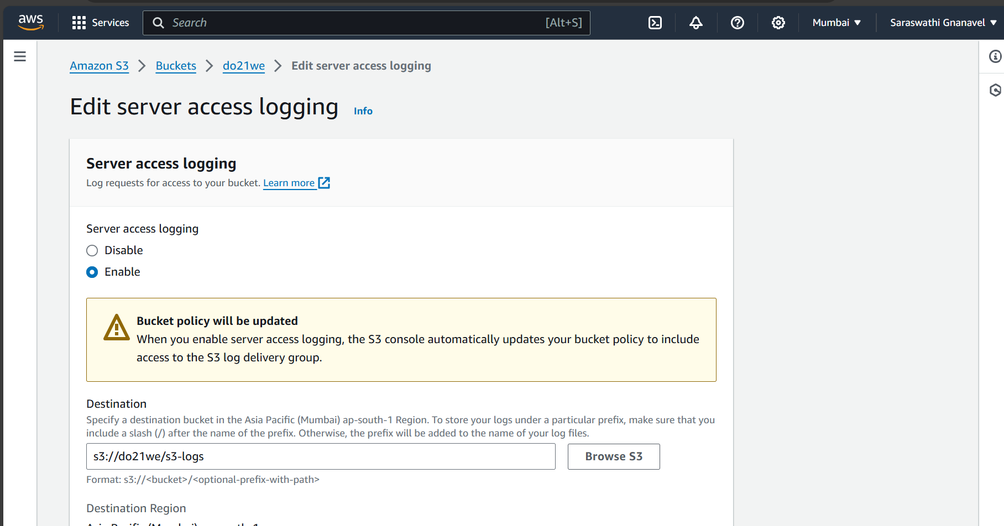

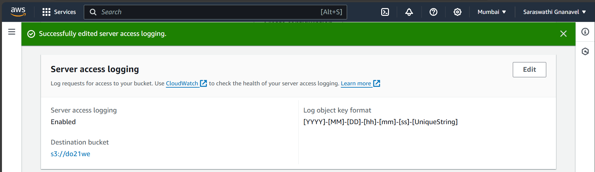

Viewing uploaded files

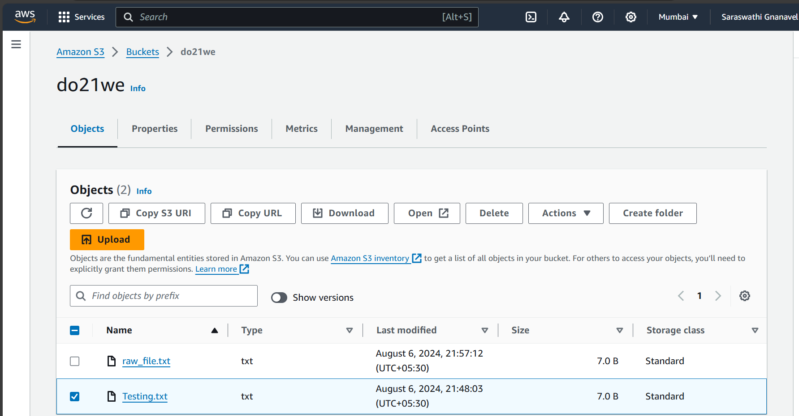

Contents present in my Testing.txt file

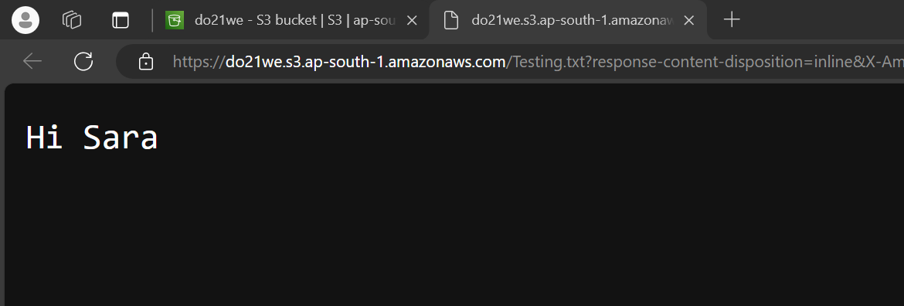

You can able to find the log file as s3-logs

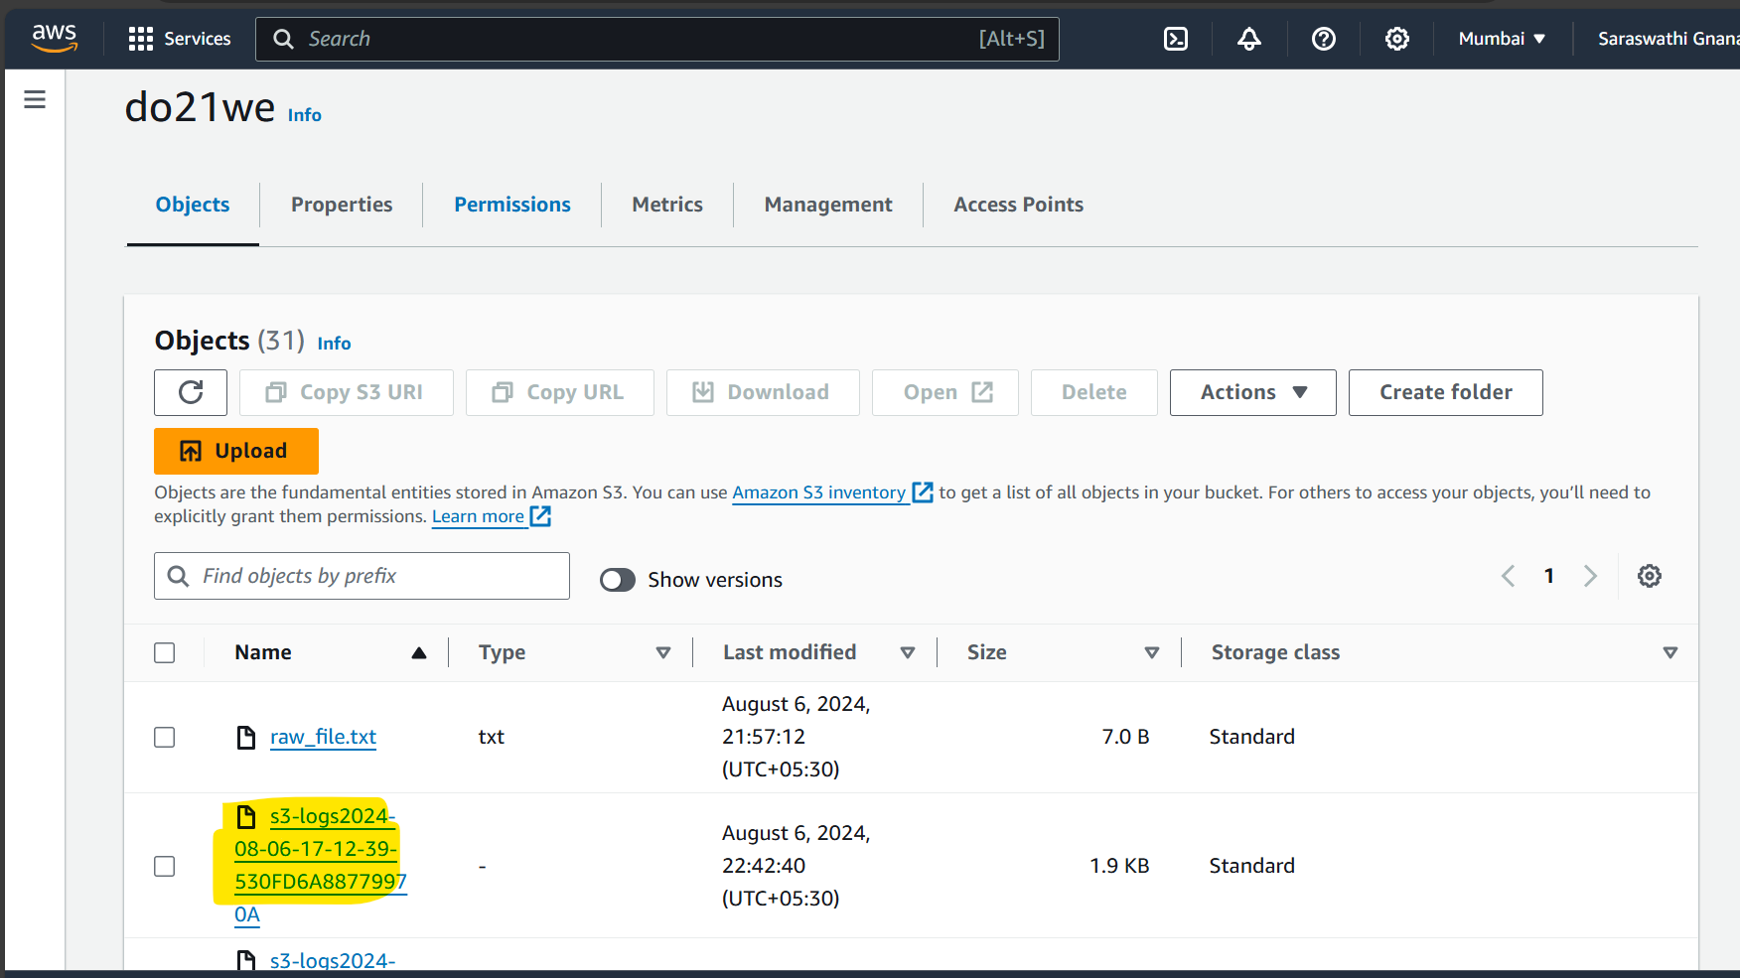

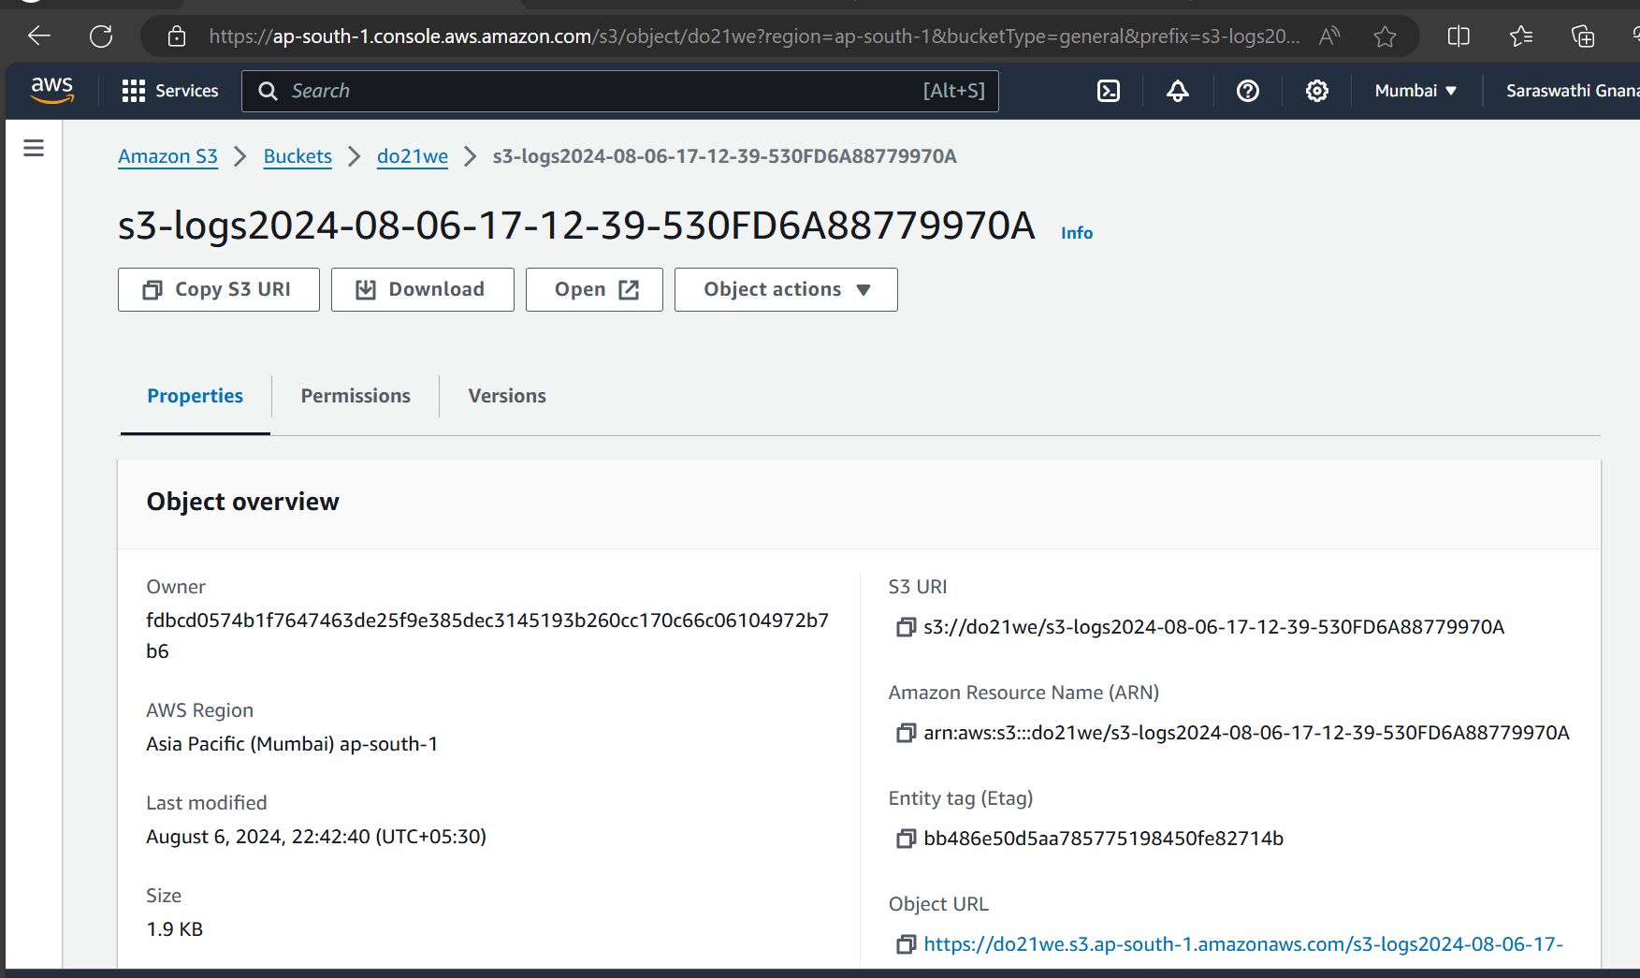

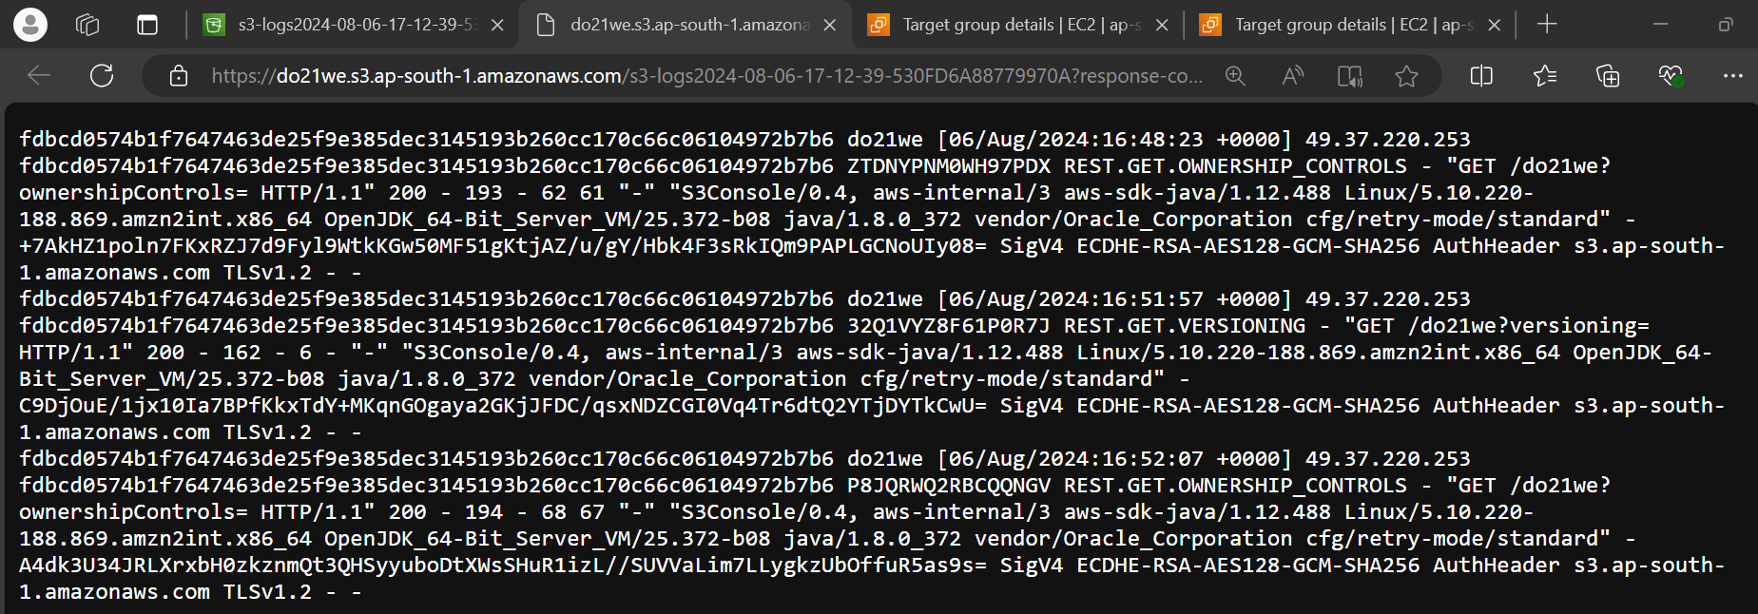

Launch two ec2-instances(Instance 1 🡪 Test1 & Instance 2 -> Test2)

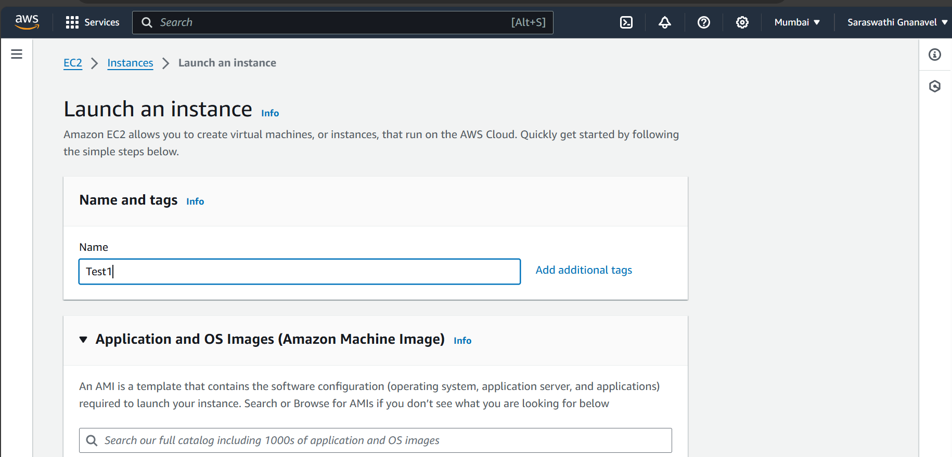

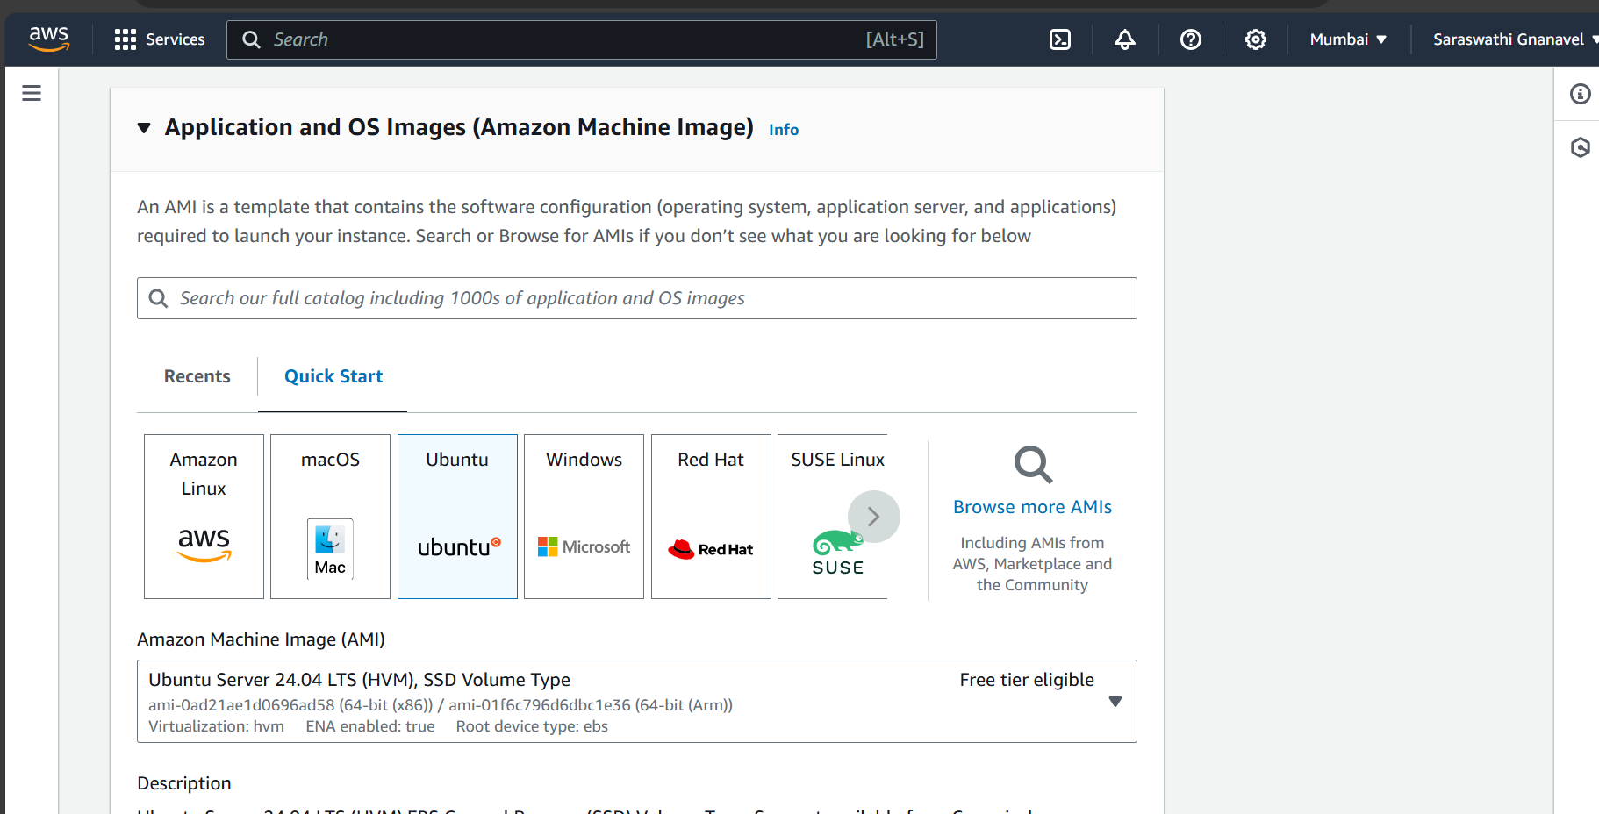

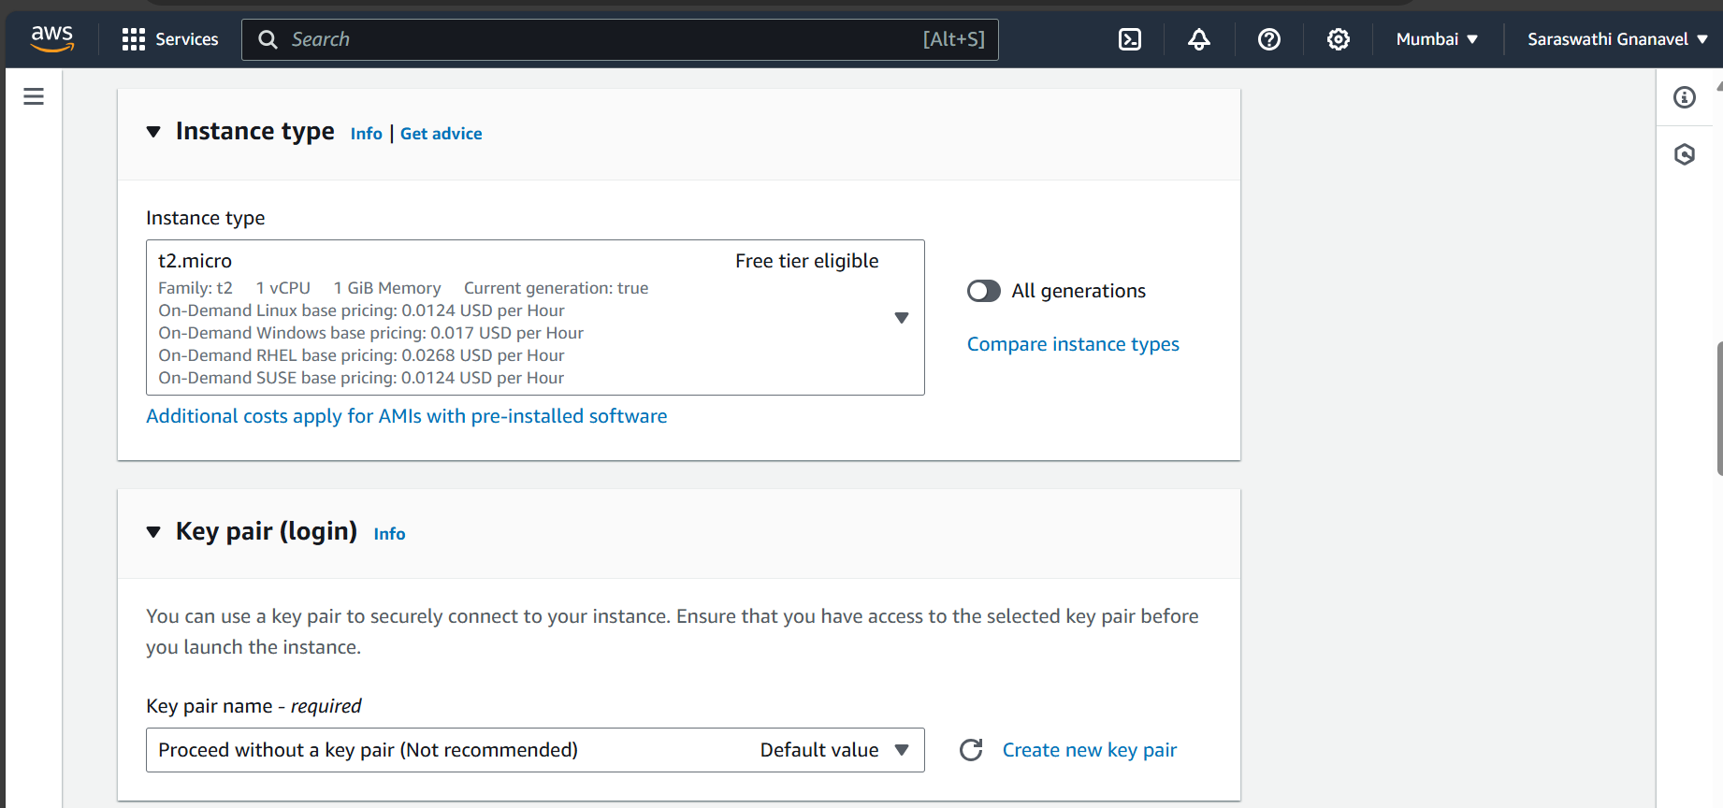

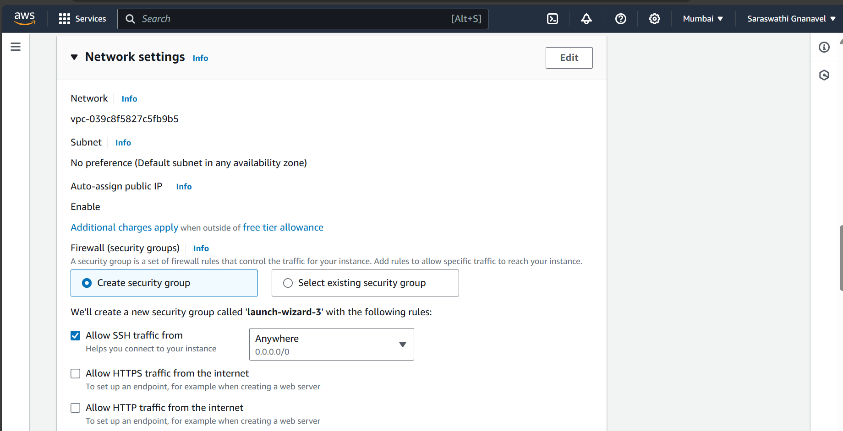

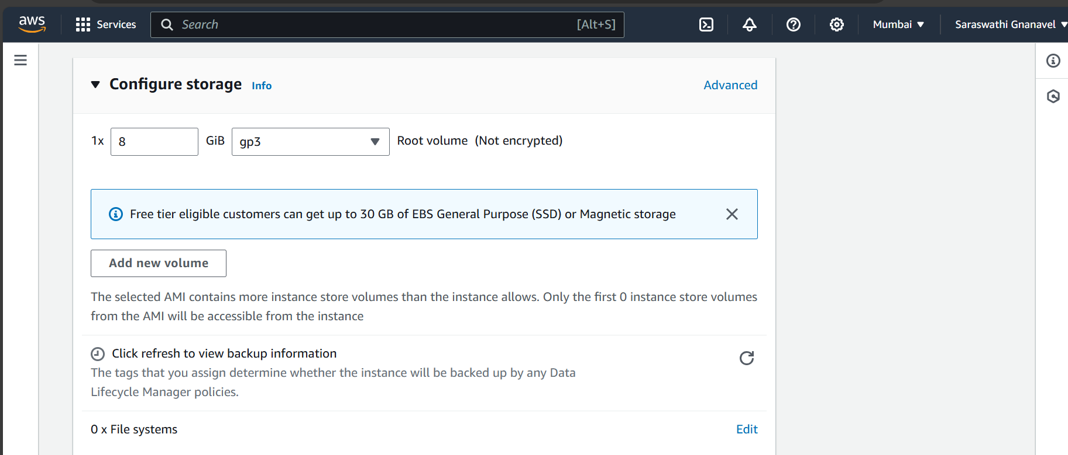

Repeat the above steps to create Instance 2 -> Test2

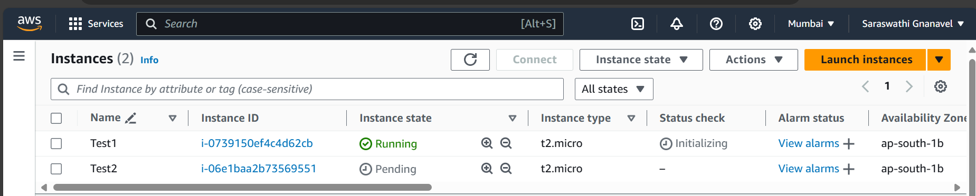

Installing web servers in both the Instances(Test1 & Test2)

Installed apache2 in Test1

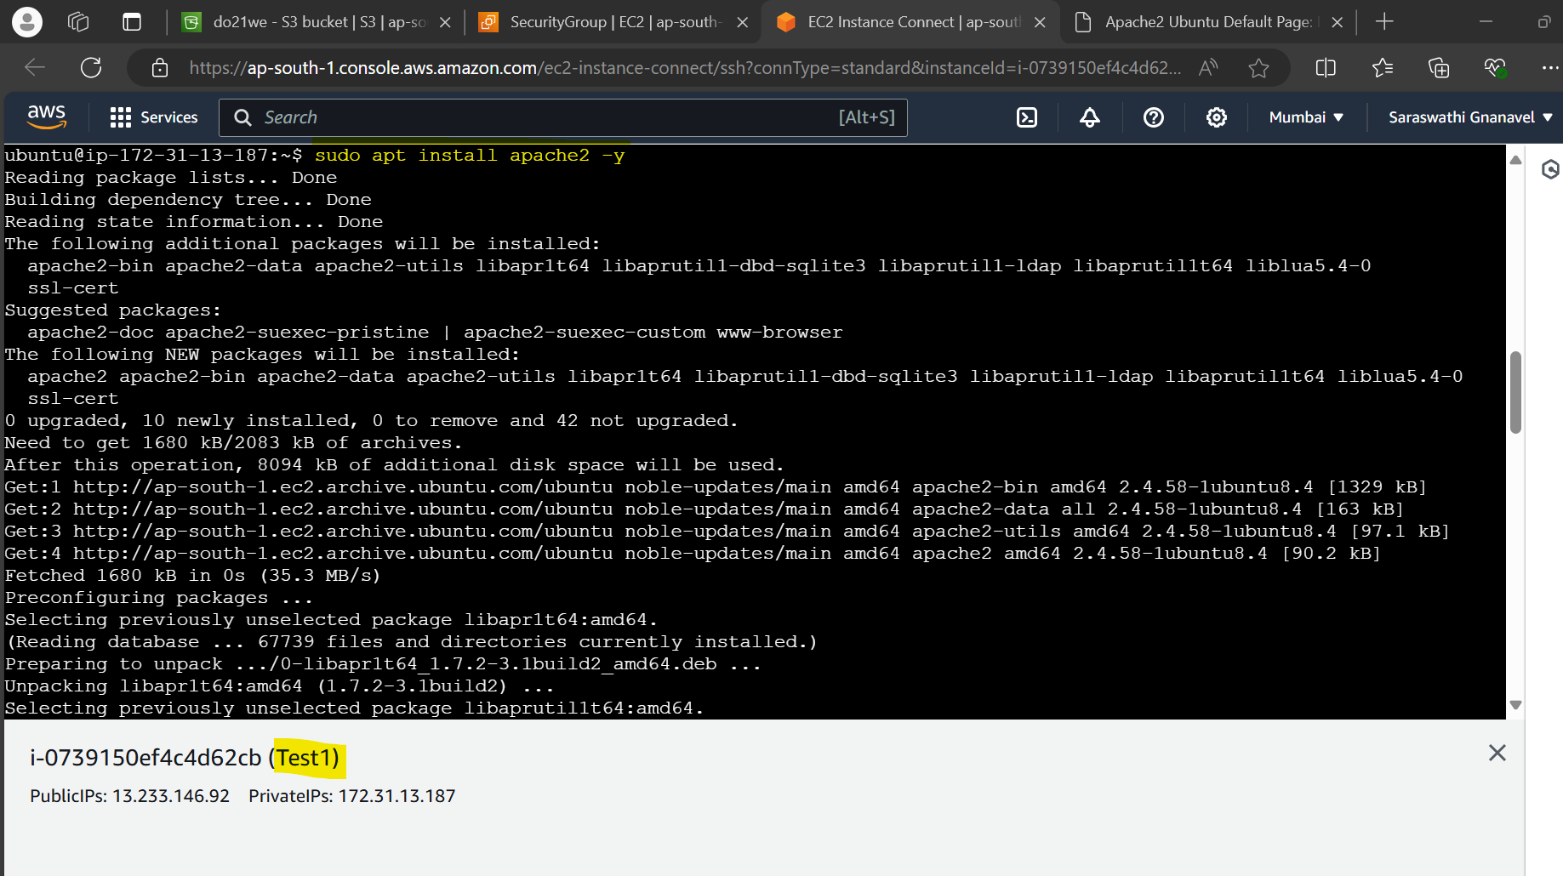

Updated its security group to run apache2 web server

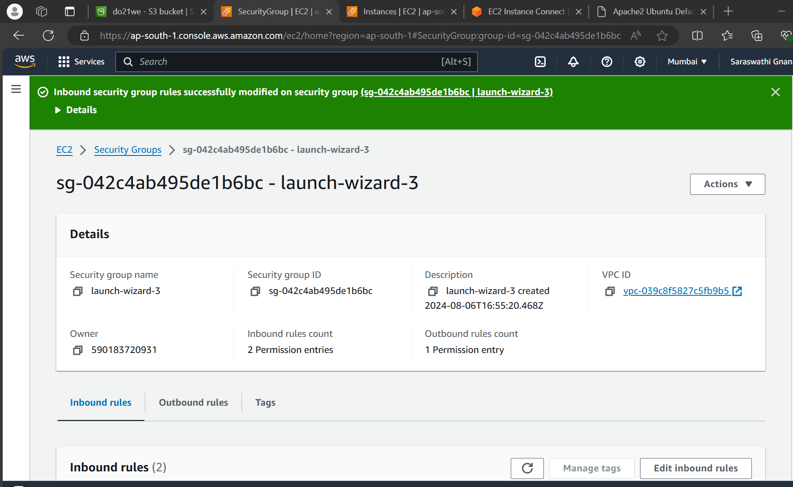

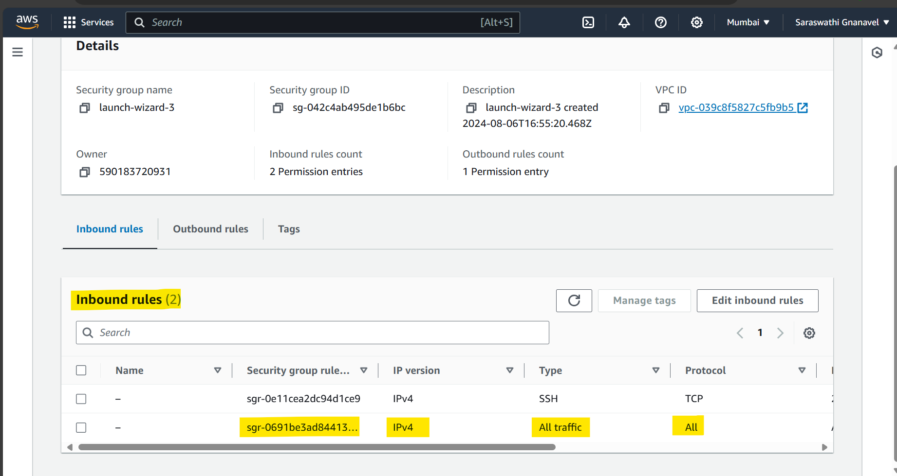

Apache2 web server is running using public Ip of Test1 instance for now

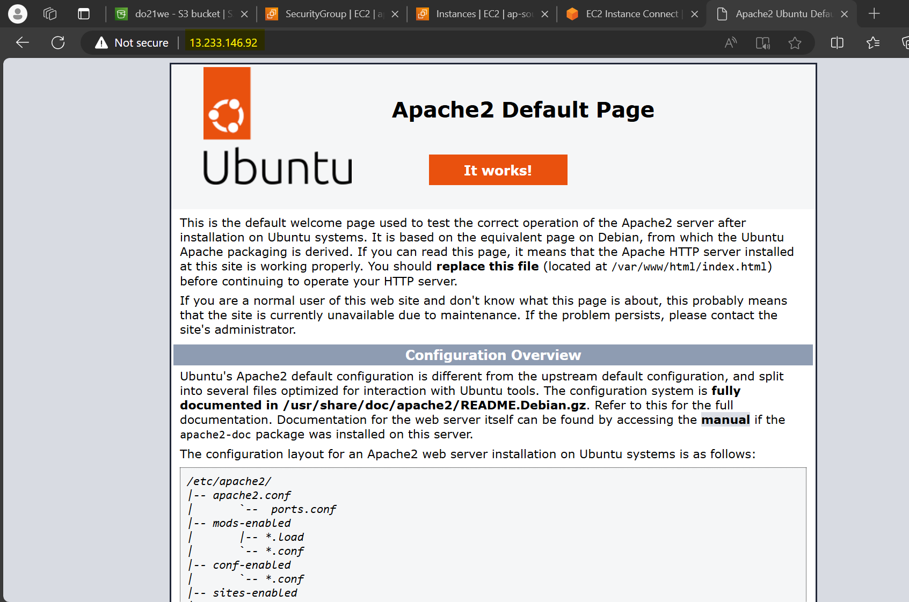

Installing apache2 in Test2 instance as well by performing the above steps

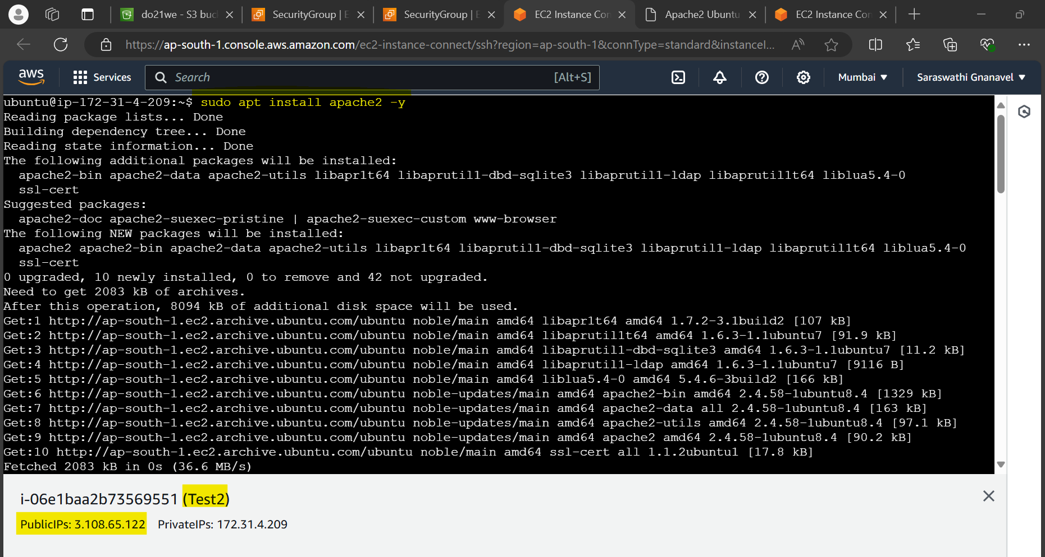

Add inbound rules at security group of Test2 instance

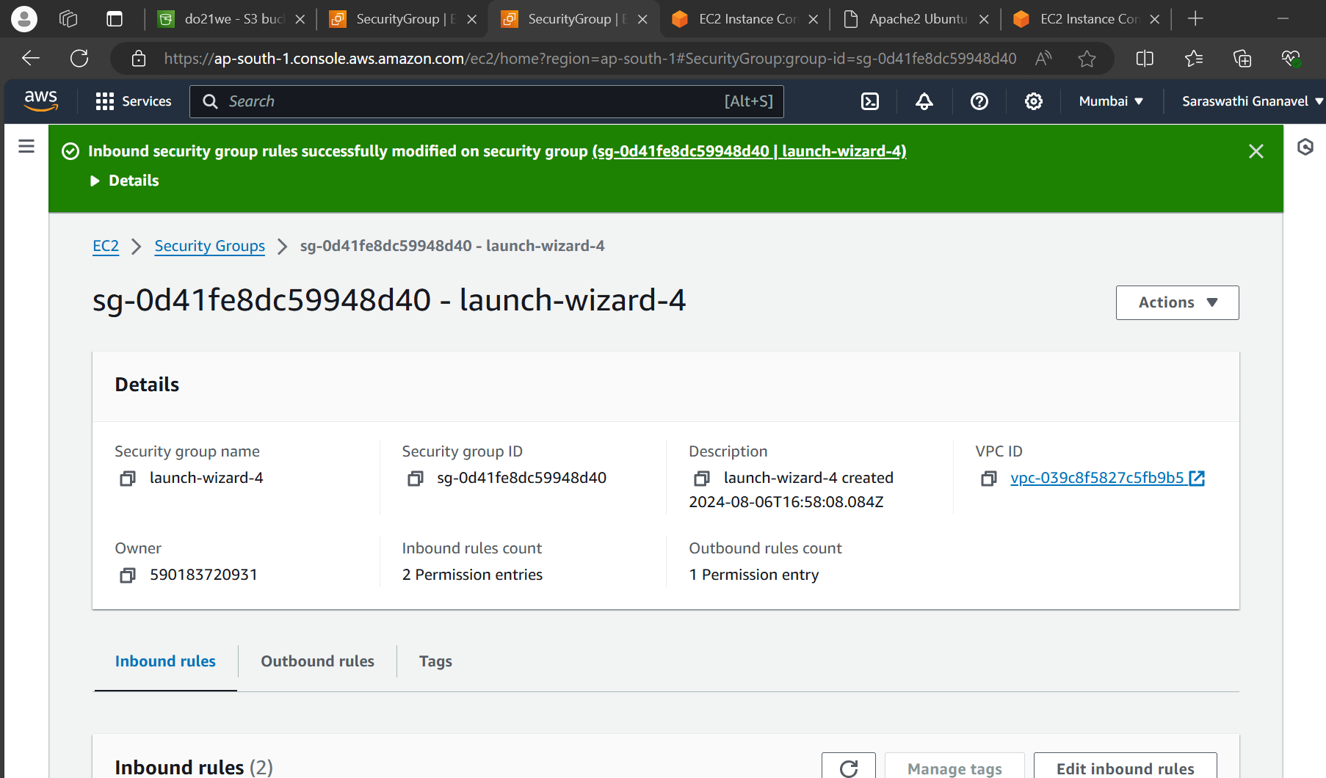

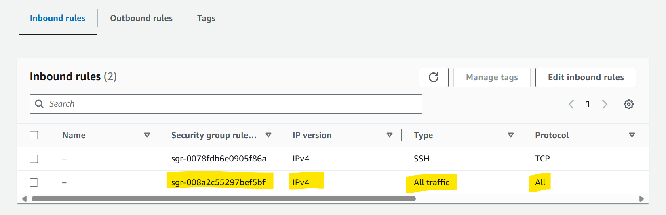

Apache2 web server is running using public Ip of Test2 instance for now

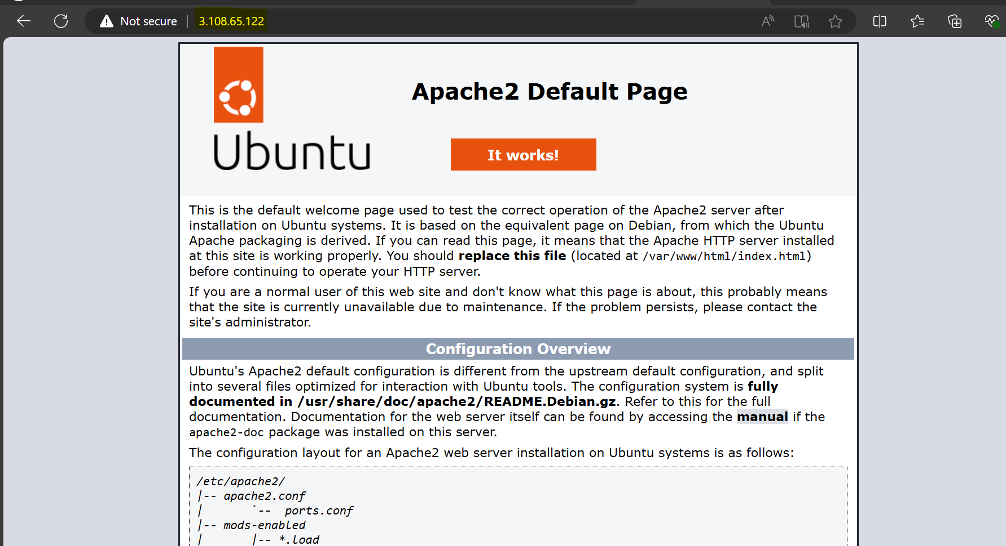

Creating Target group(Target group name -> TG1)

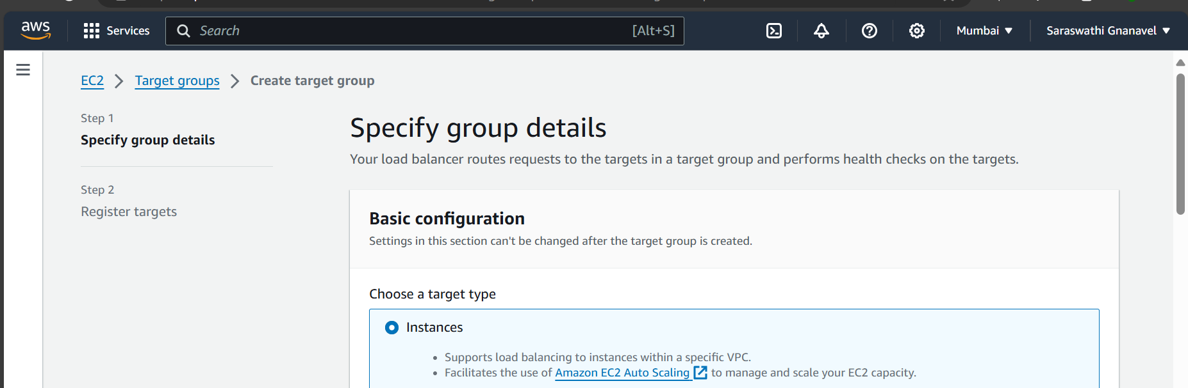

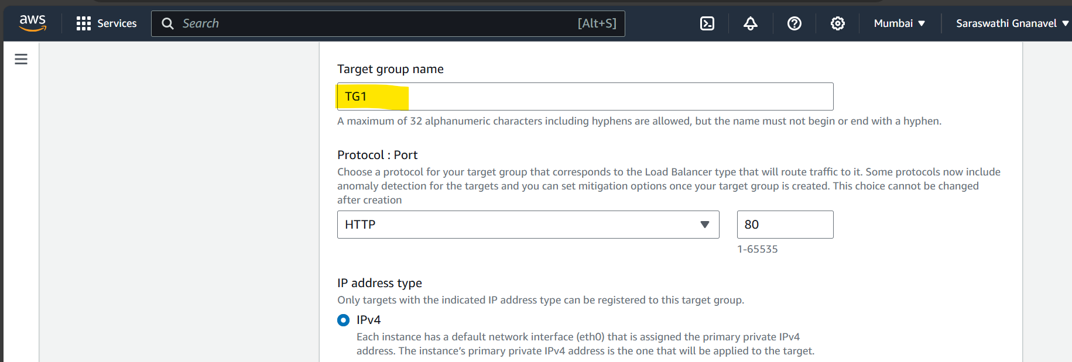

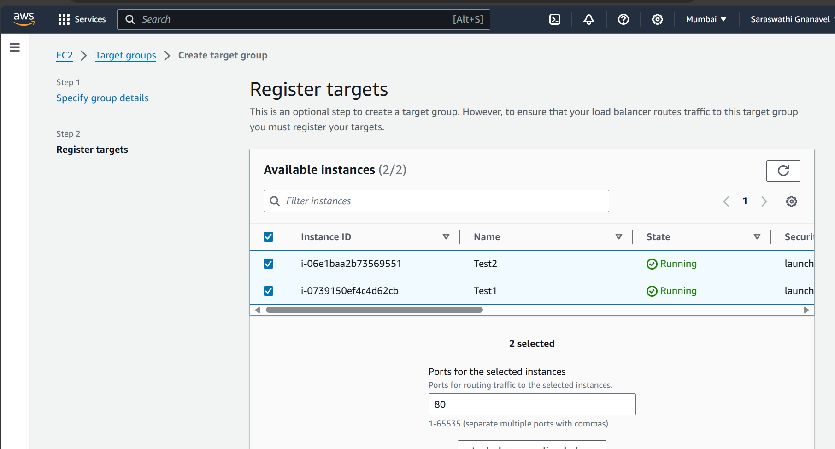

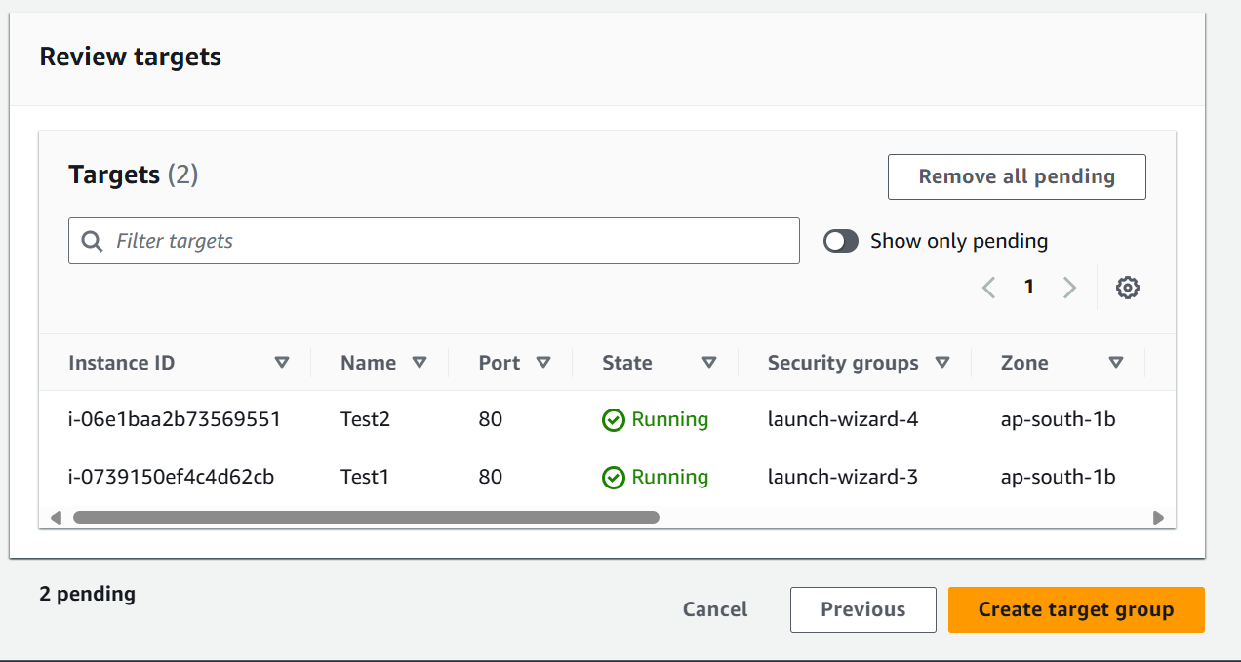

Target group has been created successfully

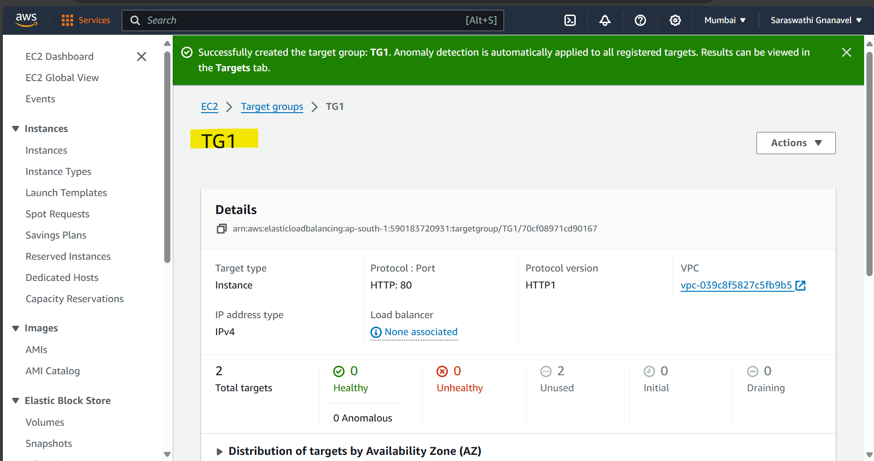

Creating Load Balancer now(Load balancer name -> ALB1)

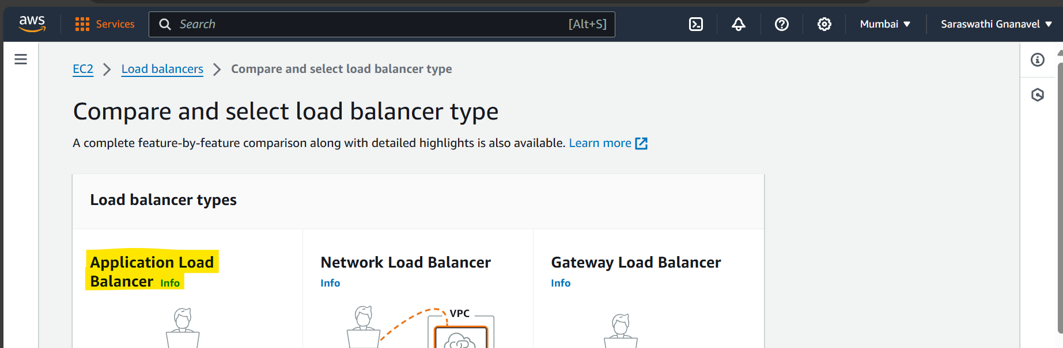

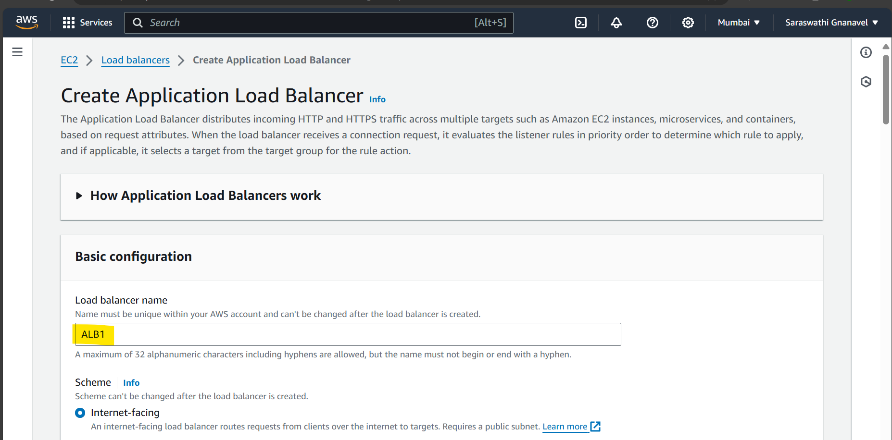

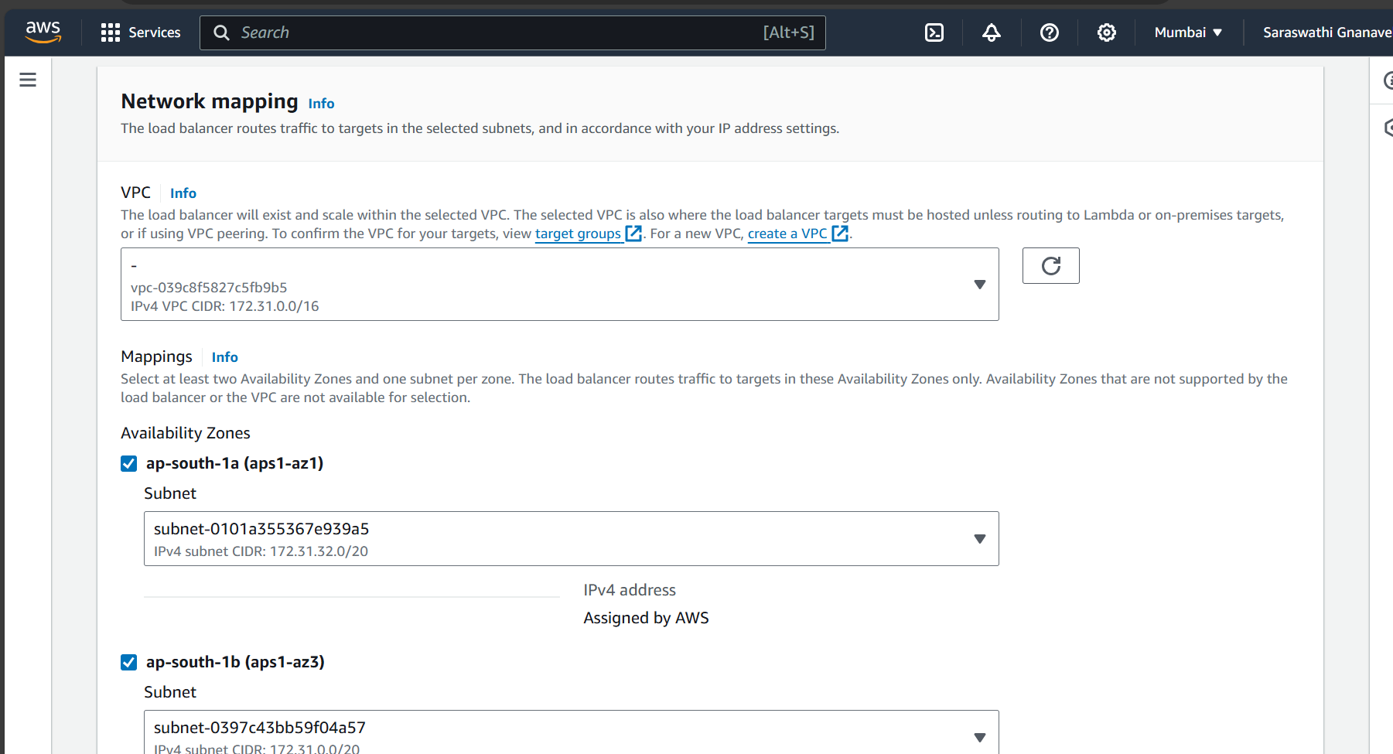

Selected TG1 Target group

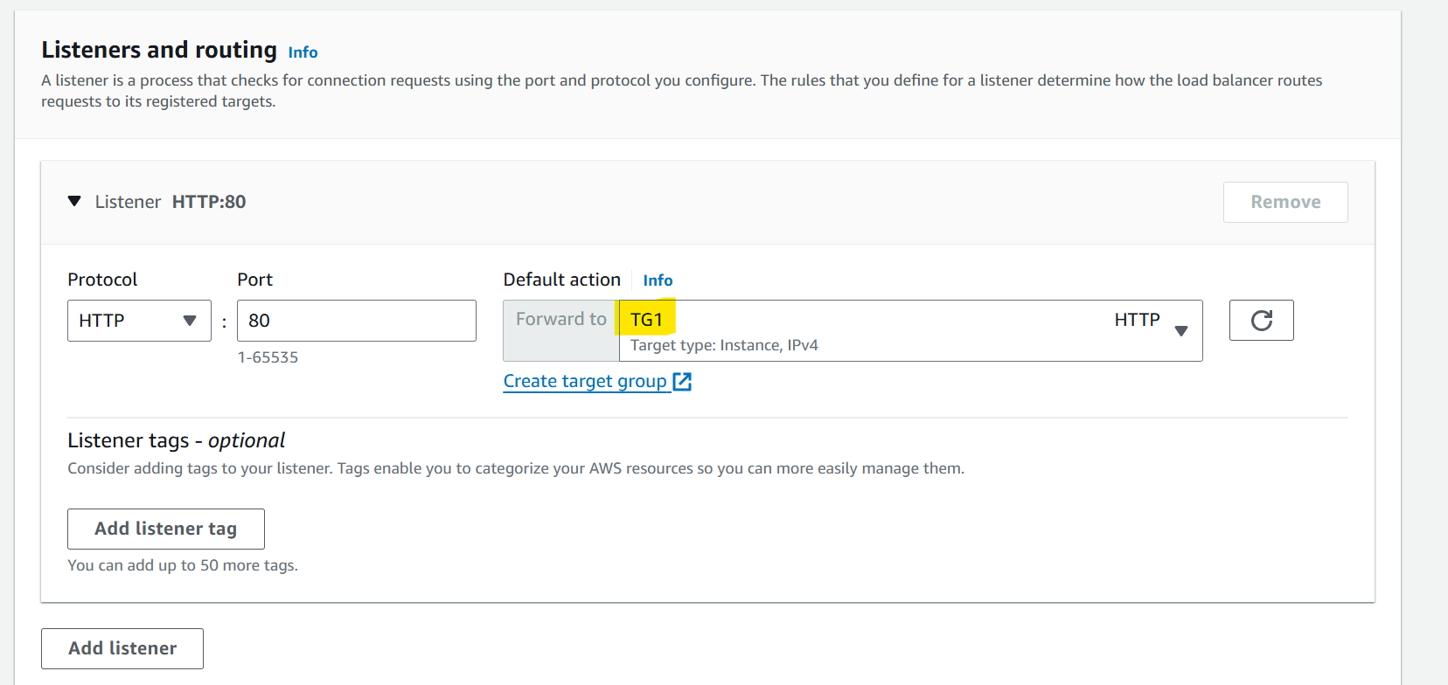

Load balancer became Active now, use the DNS to launch the web server

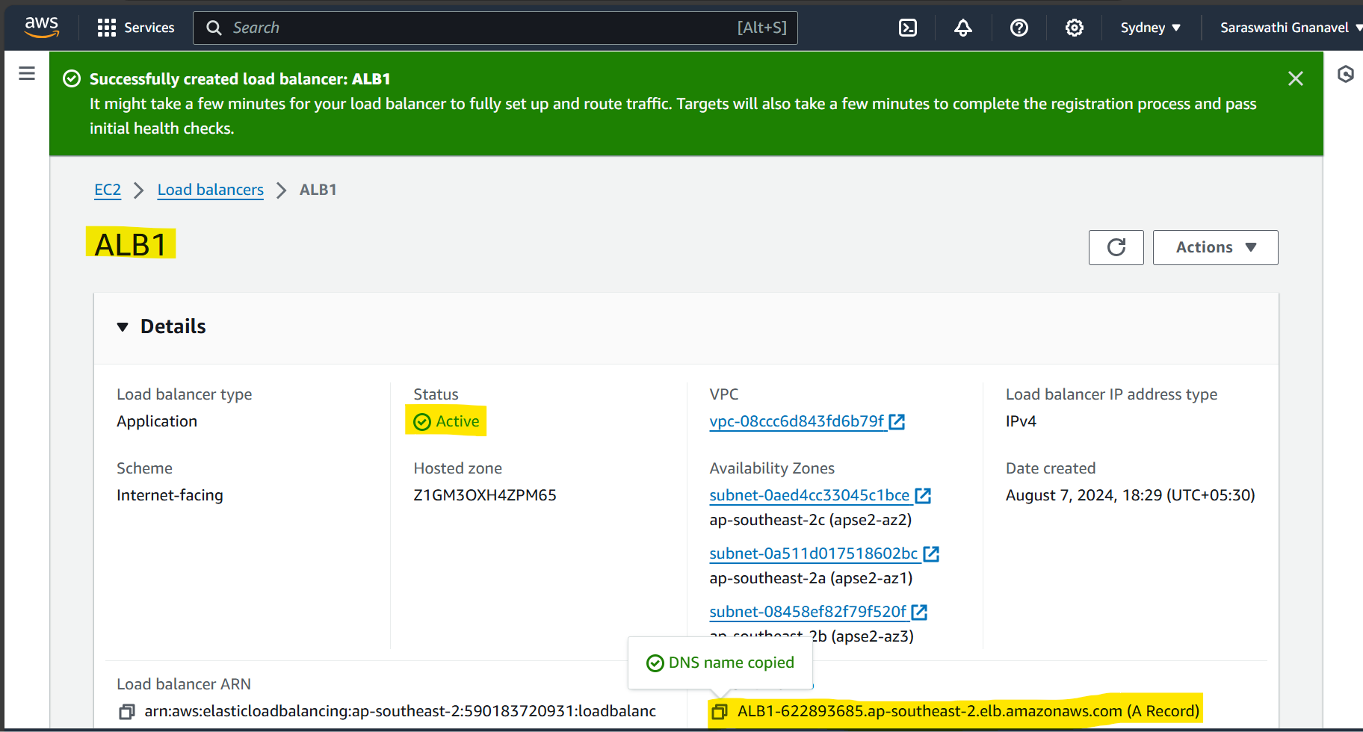

Accessed web server by using DNS, output traffic from the server transferred to load balancer IP address

